November 5, 2024

ROBERT & NANCY KNUTSON

17644 HYACINTH CT

LAKEVILLE, MN 55044

RE: Operating Permit Transfer

Operating Permit #: OP 181

Parcel #: 24-1-091901

Dear Residents:

Our office received notice that the above-referenced parcel recently transferred owners. The septic system serving this property is a non-standard system, which requires an operating permit to ensure proper monitoring and maintenance of the system. Operating permits are not transferable as to person; therefore, I have enclosed a transfer application along with a copy of the current operating permit. Please review this permit thoroughly to become acquainted with the monitoring, maintenance, and renewal requirements, then complete the application form and return it to our office.

The permittee is responsible for privately hiring and contracting with a licensed Service Provider for the maintenance and monitoring requirements of the operating permit. Their cost of service is separate to our department’s permit renewal fee. In addition to the transfer application, please include a signed maintenance contract with the Service Provider.

Before the operating permit expiration date, our office will send you a reminder notice to renew the operating permit. This reminder notice will ask that you provide:

1. Maintenance & Monitoring Report by the Service Provider
2. Renewal Application and Payment (the current renewal fee is $150).

If you have any questions about the operating permit or renewal requirements, please contact me at (218) 927-7381 or email [aitkinpz@co.aitkin.mn.us](mailto:aitkinpz@co.aitkin.mn.us)

Thank you,

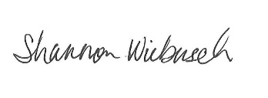

Shannon Wiebusch

Office Assistant

Aitkin County Planning & Zoning

218-927-7381