The trees removed from the site are dominantly red maple and black ash. The trees in the surrounding area are black ash, red maple and yellow birch. Understory vegetation includes ferns and sedges. All species mentioned are common wetland species.

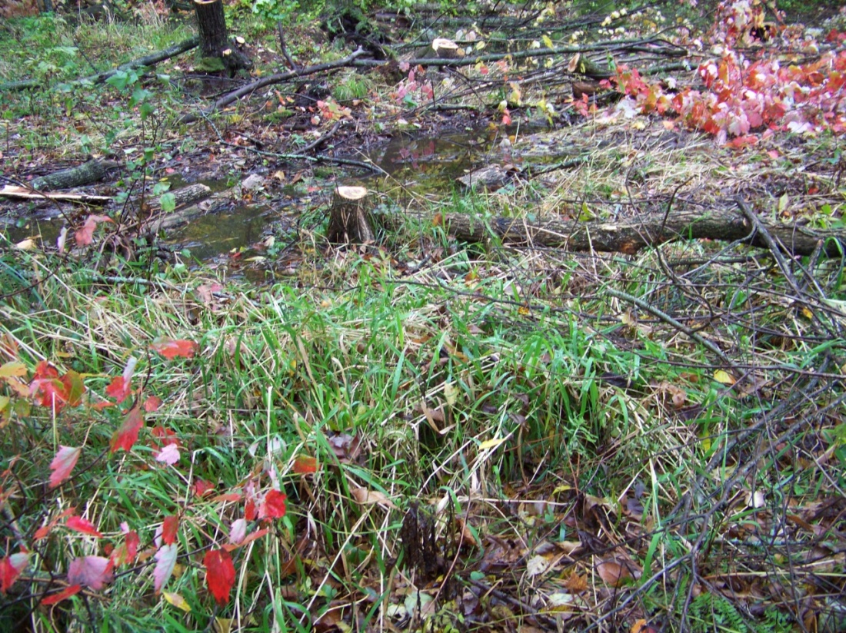

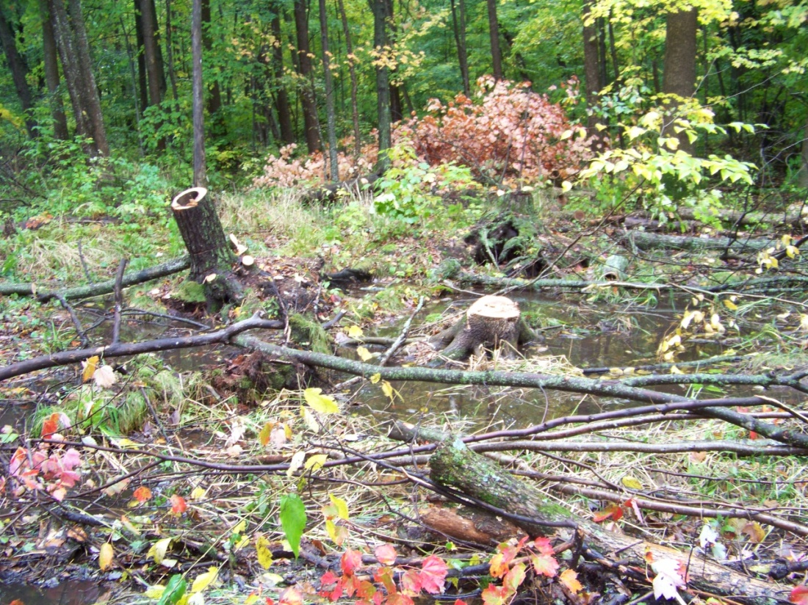

The soils are hydric within 4 inches of the surface. The site position is in a depressional area and consistent with wetland landscape position and topography.

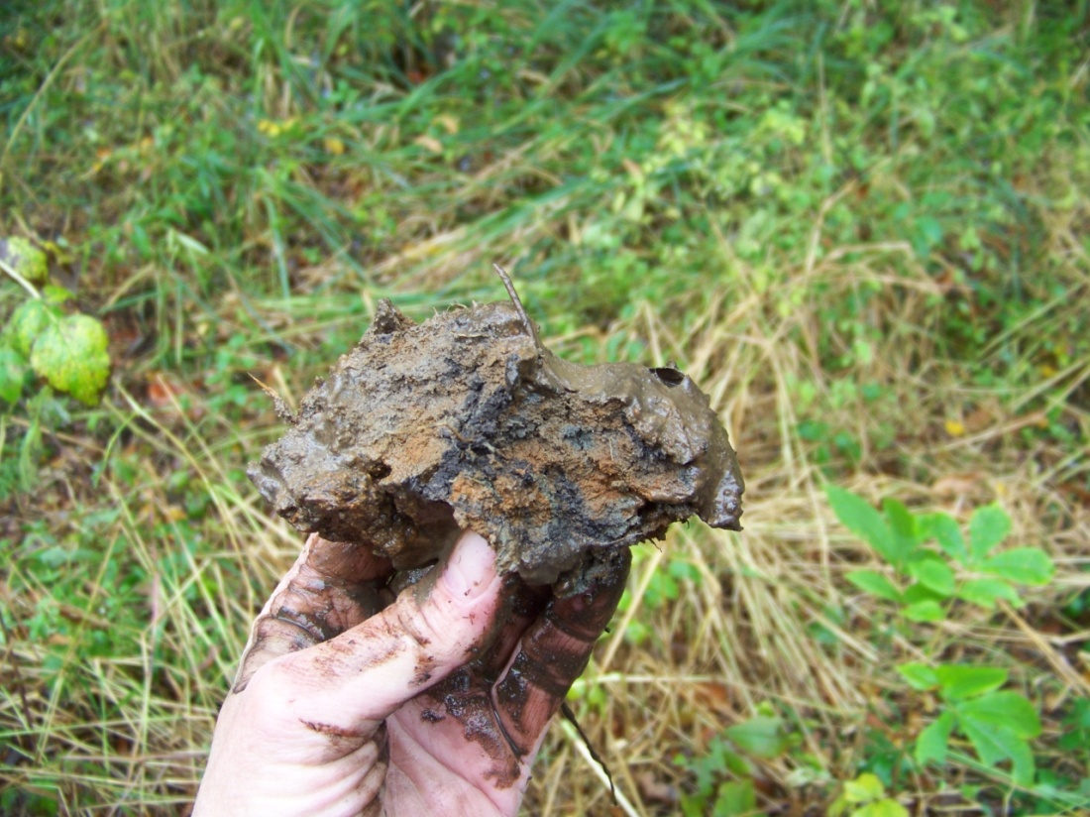

Below is the land across the driveway, which is also wetland.

